


 |  |  | Food Policy
 |  |  | June 2023
Document title |  |  |  | Food Policy
Author (name & role title) |  |  |  | Amy Thain - School Business Manager
Version number |  |  |  | V1
Date approved |  |  |  | 27 June 23
Review cycle |  |  |  | Every 3 Years
Approved by |  |  |  | Senior Leadership Team
Date of review |  |  |  | 27 June 2026
Document history
Version | Date | Author |  | Note of revisions
V1 | June 2023 | AT |  | New Policy

Page 1 of 7

Heathermount School is owned and operated by Cavendish Education. This policy is one of a series of school policies that, taken together, are designed to form a comprehensive statement of the school’s aspiration to provide an outstanding education for each of its students and of the mechanisms and procedures in place to achieve this. Accordingly, this policy should be read alongside these policies. In particular, it should be read in conjunction with the policies covering equality and diversity, Health and Safety, safeguarding and child protection.

All of these policies have been written, not simply to meet statutory and other requirements, but to enable and evidence the work that the whole school is undertaking to ensure the implementation of its core value of building confidence and preparing students for life.

While this current policy document may be referred to elsewhere in Heathermount School documentation, including particulars of employment, it is non-contractual.

In the school’s policies, unless the specific context requires otherwise, the word “parent” is used in terms of Section 576 of the Education Act 1996, which states that a ‘parent’, in relation to a child or young person, includes any person who is not a biological parent but who has parental responsibility, or who has care of the child. Department for Education guidance Understanding and dealing with issues relating to parental responsibility considers a ‘parent’ to include:

- all biological parents, whether they are married or not.

- any person who, although not a biological parent, has parental responsibility for a child or young person - this could be an adoptive parent, a step-parent, guardian or other relative

- any person who, although not a biological parent and does not have parental responsibility, has care of a child or young person.

- A person typically has care of a child or young person if they are the person with whom the child lives, either full or part time and who looks after the child, irrespective of what their biological or legal relationship is with the child.

The school employs the services of the following consulting companies to ensure regulatory compliance and the implementation of best practice:

- Peninsula BrightHR

- Peninsula BusinessSafe (Health and Safety)

- Atlantic Data (DBS)

- Educare (online CPD)

- Marsh Commercial (Insurance)

Heathermount School is committed to safeguarding and promoting the welfare of children and young people and expects all staff, volunteers, pupils and visitors to share this commitment. All outcomes generated by this document must take account of and seek to contribute to safeguarding and promoting the welfare of children and young people at Heathermount School. The policy documents of Heathermount School are revised and published periodically in good faith. They are inevitably subject to revision. On occasions a significant revision, although promulgated in school separately, may have to take effect between the re-publication of a set of policy documents. Care should therefore be taken to ensure, by consultation with the Senior Leadership Team, that the details of any policy document are still effectively current at a particular moment.

Page 2 of 7

 | Index
1 | Introduction | 4
2 | Aims and Objectives | 4
3 | Guidelines | 4
4 | School lunches and packed lunches | 5
5 | Food across the curriculum | 5
6 | Partnership with parents | 5
7 | Rationale | 6
8 | Menu planning | 6
9 | Special dietary requirements | 6
10 | Exemptions to the School Food Regulations | 6

Page 3 of 7

- Introduction

At Heathermount school, we follow the School Food Standards Guidance. This guidance ensures that children develop healthy eating habits and ensure they obtain the energy and nutrition they need throughout the school day.

We support the '5-A-DAY' ethos which encourages children to eat five portions of fruit and vegetables a day, which has been shown to reduce the onset of certain life-threatening conditions, as well as being helpful in tackling and preventing childhood obesity.

Staff work very closely with parents and children to ensure that there is understanding and awareness of sensory issues that many autistic children have, affecting food choices. In a supportive and collaborative way, staff will encourage children to try different foods and widen their food choices.

- Aims and Objectives

  - To promote health awareness and to ensure that we are giving consistent messages about food and health which contribute to the healthy physical development of all members of our school.

  - To enable students to make healthy food choices through the provision of information and development of appropriate skills and attitudes.

  - To provide healthy food choices throughout the school day and to encourage all children to eat more fruit and vegetables each day.

  - To review the formal curriculum to ensure information relating to food and nutrition in different lesson areas is consistent and up to date.

  - To ensure the provision of drinks provided by the school catering contractor meet the relevant standards.

  - To ensure that all teachers with responsibility for the formal food curriculum have basic food hygiene training.

  - To ensure that all catering staff are equipped with appropriate skills and knowledge to successfully implement the Government’s National Criteria.

  - To ensure that all staff who work with food in school have the appropriate level of food hygiene training.

- Guidelines

The school is committed to ensuring that the provision of lunches and other food and drink provided meets the school food standards.

There is not a requirement for lunches to be hot meals, however hot lunches will be provided wherever possible to ensure that all students are able, if they wish, to eat at least one hot meal every day.

Water is available, freely accessible and free of charge always on the school premises.
Fresh fruit is provided by the school if required as a healthy snack during the day.

Either a hot school lunch or sandwiches or jacket potatoes are available daily. School lunches are provided free of charge for those students eligible for free school meals.

Facilities are provided free of charge for all students to eat the food they bring to school and who are not taking school meals. These facilities include accommodation, furniture and supervision so that students can eat food they have brought from home in a safe and social environment.

Page 4 of 7

Food and nutrition are taught at an appropriate level through the curriculum throughout school. The Eatwell Guide is used as a model of understanding a balanced diet.

- School lunches and packed lunches

All our school meals are cooked by our in-house kitchen staff who follow the safer food, better business guidelines and work in line with the food hygiene standards. We provide a hot and cold option, both of which pay regard to nutritional balance alongside dietary and religious requirements. Children may choose to bring a packed lunch to school but are requested to follow the guidelines set out in the partnership with parents’ section below.

Water is freely available throughout the school day to all members of the school.

- Food across the curriculum

Across the school, there are many opportunities for pupils to develop knowledge and understanding of health, including healthy-eating patterns and practical skills that are needed to understand where food comes from such as shopping, preparing and cooking food.

  - Literacy provides children with the opportunity to explore poetry, persuasion, argument and narrative work using food and food-related issues as a stimulus, e.g., writing to a company to persuade them to use non-GM foods in children's food and drink etc.

  - Maths can offer the possibility of understanding nutrition labelling, calculating quantities for recipes, weighing and measuring ingredients.

  - Science provides an opportunity to learn about the types of food available, their nutritional composition, digestion and the function of different nutrients in contributing to health, and how the body responds to exercise.

  - Catering provides the opportunity to gain experience about where food comes from and apply healthy-eating messages through practical work with food, including preparation and cooking.

  - PSHE encourages young people to take responsibility for their own health and well-being, teaches them how to develop a healthy lifestyle and addresses issues such as body image. Pupils can discuss issues of interest to young people, e.g., advertising and sustainable development.

  - Music can explore songs which link to the theme of food.

  - Geography provides a focus on the natural world and changing environment, offering the chance to consider the impact our consumer choices have on people across the world who rely on growing food as their source of income.
  - History provides insight into changes in diet and food over time.

  - Physical Education provides pupils with the opportunity to develop physically and to understand the practical impact of sport, exercise and other physical activity such as dance and walking.

  - The greenhouses and allotment areas are used across to encourage children to grow a range of fruits and vegetables which can then be used to cook with.

- Partnership with parents

The partnership of home and school is critical in shaping how children and young people behave, particularly where health is concerned. Each must reinforce the other.

We ask parents not to send in fizzy drinks and we remind them that only water may be drunk during the school day, except at lunch when children may drink juice or squash.

We are a ‘nut free school.’ Parents are reminded that, due to the severity of some allergies in school and the difficulty in managing allergies and preferences when children bring treats into school.

Page 5 of 7

- Rationale

Heathermount is a healthy school, and it is important that we consider all elements of our work to ensure that we promote health awareness in all members of the school community. We aim to be valuable role models to pupils and their families about food and healthy-eating patterns.

Through effective leadership, the school ethos and the curriculum, all school staff can bring together all elements of the school day to create an environment which supports a healthy lifestyle. Providing an environment that promotes healthy eating and provides nutritious food and drink enables students to make informed choices about the food they eat.

- Menu planning

  - Menus are designed to adhere to the Eatwell guide (see appendix 1) and to ensure that they appeal to the students in the school.

  - Children and parents are consulted on a yearly basis regarding the menus offered within school.

  - Menus are planned to repeat three-weekly and are reviewed termly.

  - Meals meet the legal requirements on food standards.

- Special dietary requirements
  - There is a strong process in place to check and manage allergies.

  - The school will endeavour wherever possible to accommodate students’ specialist dietary requirements including allergies, intolerances, religious or cultural practices.

  - The school expects staff to support this food policy across the school day.

  - Staff and visitors will be expected to model good practice behaviour around food and drink and in line with the policy, when in the company of students.

  - All staff working in the kitchen and food technology teachers have a minimum level 2 food hygiene qualification.

  - Please note that for some social or fundraising activities organised by the school exceptions may be made to the general guidance noted above.

References:
School Food Standards
School Food in England
Preparing varied and tasty menus
Portion sizes and food groups
Allergy guidance for schools
Safer food better business guidelines
Food hygiene standards

Page 6 of 7

Appendix 1: The Eatwell Guide
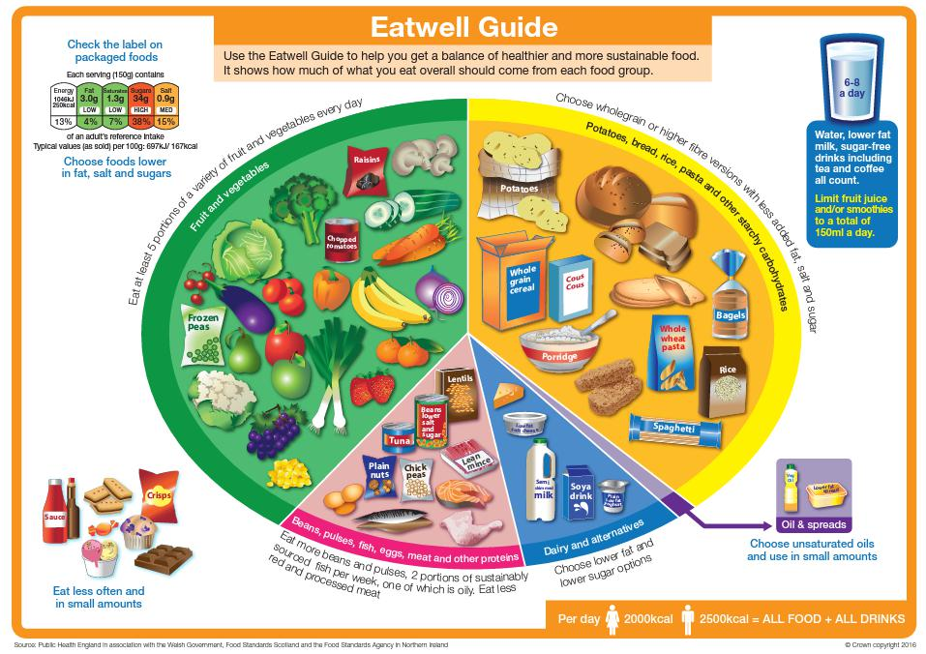

Page 7 of 7

