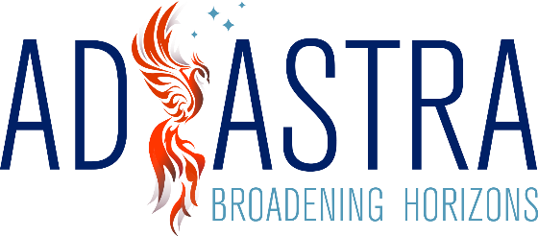

Clean Desk Policy

Ad Astra stands committed to the development of secure policies and practices, and in doing so, has implemented this Clean Desk Policy to increase physical security at our locations.
This policy ensures that confidential information and sensitive materials are stored away and out of sight when they are not in use or when the workspace is vacant.
This policy sets forth the basic requirements for keeping a clean workspace, where sensitive and confidential information about Ad Astra employees, clients, vendors, and intellectual property is secured.
The policy shall apply to all Ad Astra employees, contractors, and affiliates.

Policy
- Employees are required to secure all sensitive/confidential information in their workspace at the conclusion of the work day and when they are expected to be away from their workspace for an extended period of time. This includes both electronic and physical hardcopy information.
- Computer workstations/laptops must be locked (logged out or shut down) when unattended and at the end of the work day. Portable devices like laptops and tablets that remain in the office overnight must be shut down and stored away.
- Mass storage devices such as CD, DVD, USB drives, or external hard drives must be treated as sensitive material and locked away when not in use.
- Printed materials must be immediately removed from printers or fax machines. Printing physical copies should be reserved for moments of absolute necessity. Documents should be viewed, shared and managed electronically whenever possible.
- All sensitive documents and restricted information must be placed in the designated shredder bins for destruction or placed in the locked confidential disposal bins.
- File cabinets and drawers containing sensitive information must be kept closed and locked when unattended and not in use.
- Passwords must not be written down or stored anywhere.
- Keys and physical access cards must not be left unattended anywhere in the office.
It is the responsibility of each member of staff to ensure enforcement with the policies above. Repeated or serious violations of the clean desk policy can result in disciplinary actions in accordance with Employees contract.

If you notice that any of your devices or documents have gone missing, or if you believe your workspace has been tampered with in any way, please notify Elizabeth Shaw immediately.

Date reviewed 01-09-2023

Date to be reviewed 01-09-2024

Signed S SHAW Managing Director

